Reception class NEWSLETTER 17.06.2024 The Ugly Duckling
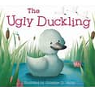  Dear Parents/Carers  This week, we will be reading the story, The Ugly Duckling.  This also links well to our class topic learning, as we learn about the Life Cycle of a duck.  There may be a special surprise this week too! Quack, quack! | Ways you can help at home: Phonics  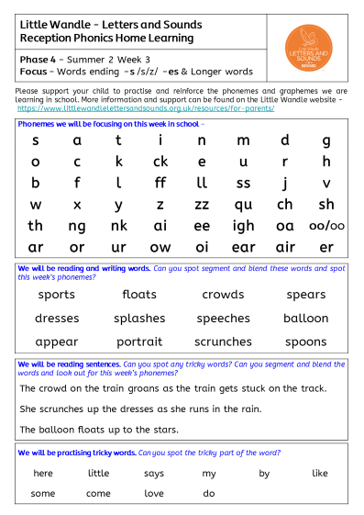
Vocabulary:
As part of our communication and language, We will also talk about new words we read in stories,
Duckling, mother, life cycle, swan, nest, winter, spring, season, hatch, escaped, egg, different, belonged, waddled, released, pond, reeds, farmer…

Ways you can help at home: Maths.
In Maths, we will be looking at teen numbers.
We will learn to read and write teen numbers correctly, including those tricky ones …11,12,13 &15.
Can you practise writing teen numbers at home? (please see the number formation mat below)

We will learn to count out objects correctly to match the given teen numbers.

We will look at the composition of teen numbers using a 20 frame, understanding that 10 add 1 more makes 11 and ten add 2 more on the 20 frame equals 12.

We will be learning to look at the 20 frames, so we can recall the teen number independently without counting.

For example:
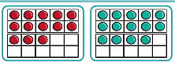

10 add 3 more=13 10 add 4more =14

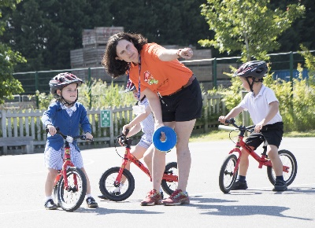
YR Bikeability lessons:

We are really looking forward to our bikeabiity lessons in school this week.
Please note - Children can only do bikeability if their parent/carer have given consent.
Please ensure you have completed the Forms links sent to you. By completing the information in this form you are consenting to your child participating in the 2024 Bike Ability sessions.
YRB will complete their training – 17th – 20th June 2024
YRG will complete their training – 24th – 27th June 2024
Helmets and balance bikes will be provided.

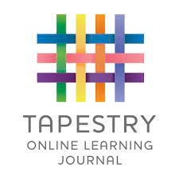
Tapestry:
Don’t forget to share your home learning and achievements at home with us on Tapestry.
Thank you, From the EYFS team

